NAME:MEGHANA GANESH
ROLL NO:26
REG NO:210905160
CSE A

LAB EXERCISE:
Configure the below topology to setup connectivity using RIPv2. R1, R2, and R3 will use
dynamic routing protocol (RIPv2).

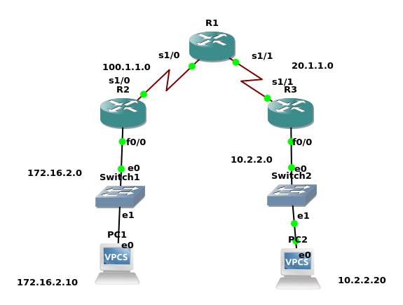
Configuration for R1
R1#conf t
R1(config)#int s1/0
R1(config-if)#ip add 100.1.1.2 255.255.255.0
R1(config-if)#no shut
R1(config-if)#int s1/1
R1(config-if)#ip address 20.1.1.1 255.255.255.0
PAGE: 81R1(config-if)#no shut
R1(config-if)#exit
R1(config)#router rip
R1(config-router)#version 2
R1(config-router)#network 20.1.1.0
R1(config-router)#network 100.1.1.0
Configuration for R2
R2#config t
R2(config)#int f1/0
R2(config-if)#ip address 172.16.2.1 255.255.0.0
R2(config-if)#no shut
R2(config-if)#int s2/0
R2(config-if)#ip address 100.1.1.1 255.255.255.0
R2(config-if)#no shut
R2(config-if)#exit
R2(config)#router rip
R2(config-router)#version 2
R2(config-router)#network 172.16.0.0
R2(config-router)#network 100.1.1.0
Configuration for R3
R3#config t
R3(config)#int s2/0
R3(config-if)#ip add 20.1.1.2 255.255.255.0
R3(config-if)#no shut
R3(config-if)#int f1/0
R3(config-if)#ip add 10.2.2.1 255.255.255.0
R3(config-if)#no shut
PAGE: 82R3(config-if)#exit
R3(config)#router rip
R3(config-router)#ver 2
R3(config-router)#network 10.2.2.0
R3(config-router)#network 20.1.1.0

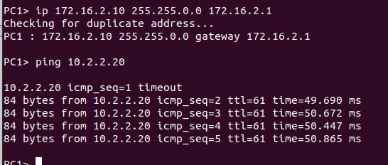

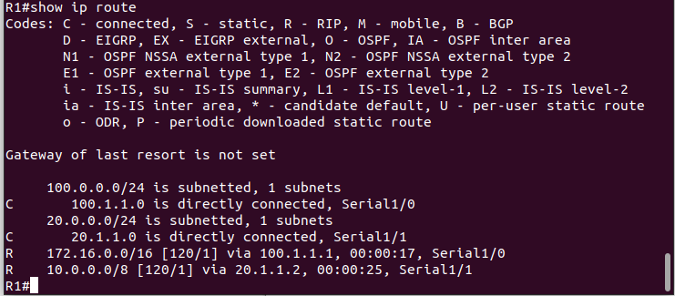

h

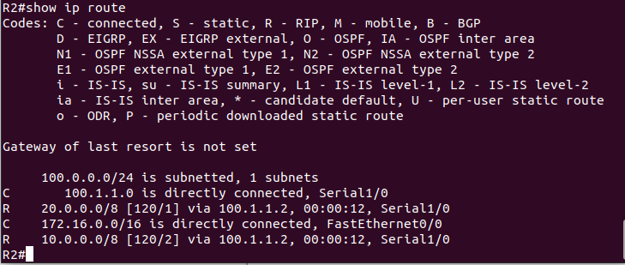

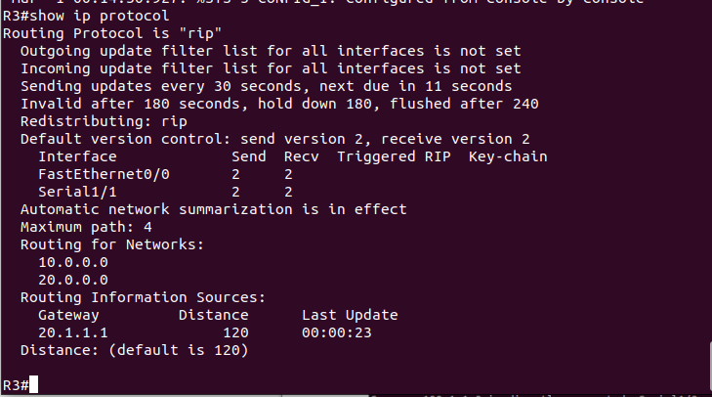

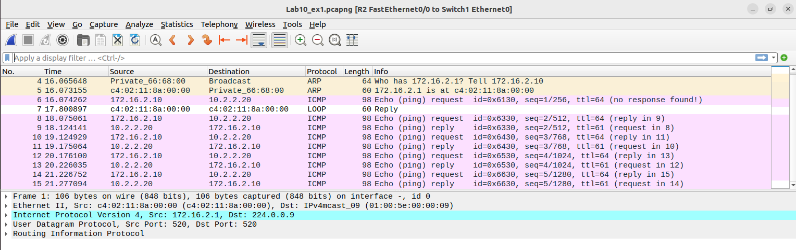

LAB EXERCISE:
Configure the below topology to setup connectivity using RIPv2. R1, R2, and R3 will use
dynamic routing protocol (OSPF).

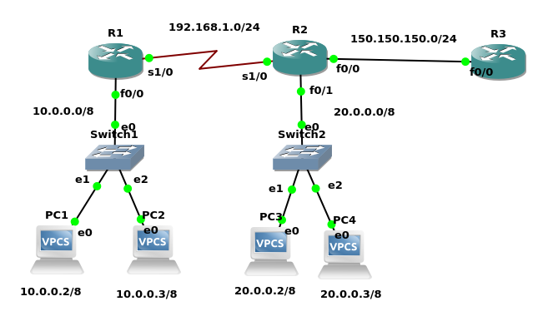
R1#conf t
Enter configuration commands, one per line. End with CNTL/Z.
R1(config)#inter s1/0
R1(config-if)#ip address 192.168.1.1 255.255.255.0
R1(config-if)#no shut
R1(config-if)#
*Mar 1 00:00:40.063: %LINK-3-UPDOWN: Interface Serial1/0, changed state to up
R1(config-if)#
*Mar 1 00:00:41.067: %LINEPROTO-5-UPDOWN: Line protocol on Interface Serial1/0, changed state to up
R1(config-if)#exit
R1(config)#inter f0/0
R1(config-if)#ip address 10.0.0.1 255.0.0.0
R1(config-if)#no shut
R1(config-if)#
*Mar 1 00:01:03.787: %LINEPROTO-5-UPDOWN: Line protocol on Interface Serial1/0, changed state to down
R1(config-if)#e
*Mar 1 00:01:06.039: %LINK-3-UPDOWN: Interface FastEthernet0/0, changed state to up
*Mar 1 00:01:07.039: %LINEPROTO-5-UPDOWN: Line protocol on Interface FastEthernet0/0, changed state to up
R1(config-if)#exit
R1(config)#router ospf 200
R1(config-router)#network 10.0.0.0 0.255.255.255 area 0
R1(config-router)#network 192.168.1.0 0.0.0.255 area 0.0.0.0
R1(config-router)#exit
R1(config)#exit

R2#conf t
Enter configuration commands, one per line. End with CNTL/Z.
R2(config)#inter s1/0
R2(config-if)#ip address 192.168.1.2 255.255.255.0
R2(config-if)#no shut
R2(config-if)#
*Mar 1 00:08:54.847: %LINK-3-UPDOWN: Interface Serial1/0, changed state to up
R2(config-if)#
*Mar 1 00:08:55.851: %LINEPROTO-5-UPDOWN: Line protocol on Interface Serial1/0, changed state to up
R2(config-if)#exit
R2(config)#inter f0/0
R2(config-if)#ip address 150.150.150.1 255.255.255.0
R2(config-if)#no shut
R2(config-if)#
*Mar 1 00:09:45.783: %LINK-3-UPDOWN: Interface FastEthernet0/0, changed state to up
*Mar 1 00:09:46.783: %LINEPROTO-5-UPDOWN: Line protocol on Interface FastEthernet0/0, changed state to up
R2(config-if)#exit
R2(config)#inter f0/1
R2(config-if)#ip address 20.0.0.1 255.0.0.0
R2(config-if)#no shut
R2(config-if)#
*Mar 1 00:10:12.907: %LINK-3-UPDOWN: Interface FastEthernet0/1, changed state to up
*Mar 1 00:10:13.907: %LINEPROTO-5-UPDOWN: Line protocol on Interface FastEthernet0/1, changed state to up
R2(config-if)#exit
R2(config)#router ospf 200
R2(config-router)#network 20.0.0.0 0.255.255.255 area 0
R2(config-router)#network 192.168.1.0 0.0.0.255 area 0
R2(config-router)#
*Mar 1 00:10:55.931: %OSPF-5-ADJCHG: Process 200, Nbr 192.168.1.1 on Serial1/0 from LOADING to FULL, Loading Done
R2(config-router)#network 150.150.150.0 0.0.0.255 area 1
R2(config-router)#exit
R2(config)#exit

R3#conf t
Enter configuration commands, one per line. End with CNTL/Z.
R3(config)#inter f0/0
R3(config-if)#ip address 150.150.150.2 255.255.255.0
R3(config-if)#no shut
R3(config-if)#
*Mar 1 00:02:23.647: %LINK-3-UPDOWN: Interface FastEthernet0/0, changed state to up
*Mar 1 00:02:24.647: %LINEPROTO-5-UPDOWN: Line protocol on Interface FastEthernet0/0, changed state to up
R3(config-if)#exit
R3(config)#router ospf 200
R3(config-router)#network 150.150.150.0 0.0.0.255 area 1
R3(config-router)#exit
R3(config)#exit

PC1> ip 10.0.0.2 255.0.0.0 10.0.0.1
Checking for duplicate address...
PC1 : 10.0.0.2 255.0.0.0 gateway 10.0.0.1

PC2> ip 10.0.0.3 255.0.0.0 10.0.0.1
Checking for duplicate address...
PC2 : 10.0.0.3 255.0.0.0 gateway 10.0.0.1

PC3> ip 20.0.0.2 255.0.0.0 20.0.0.1
Checking for duplicate address...
PC3 : 20.0.0.2 255.0.0.0 gateway 20.0.0.1

PC4> ip 20.0.0.3 255.0.0.0 20.0.0.1
Checking for duplicate address...
PC4 : 20.0.0.3 255.0.0.0 gateway 20.0.0.1

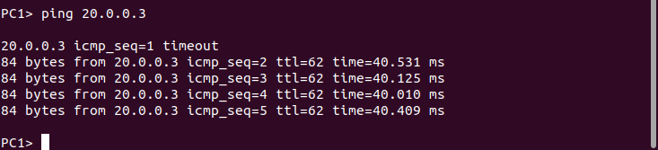

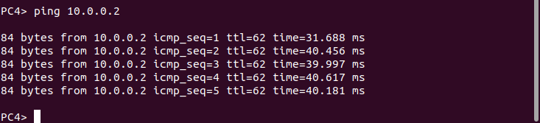

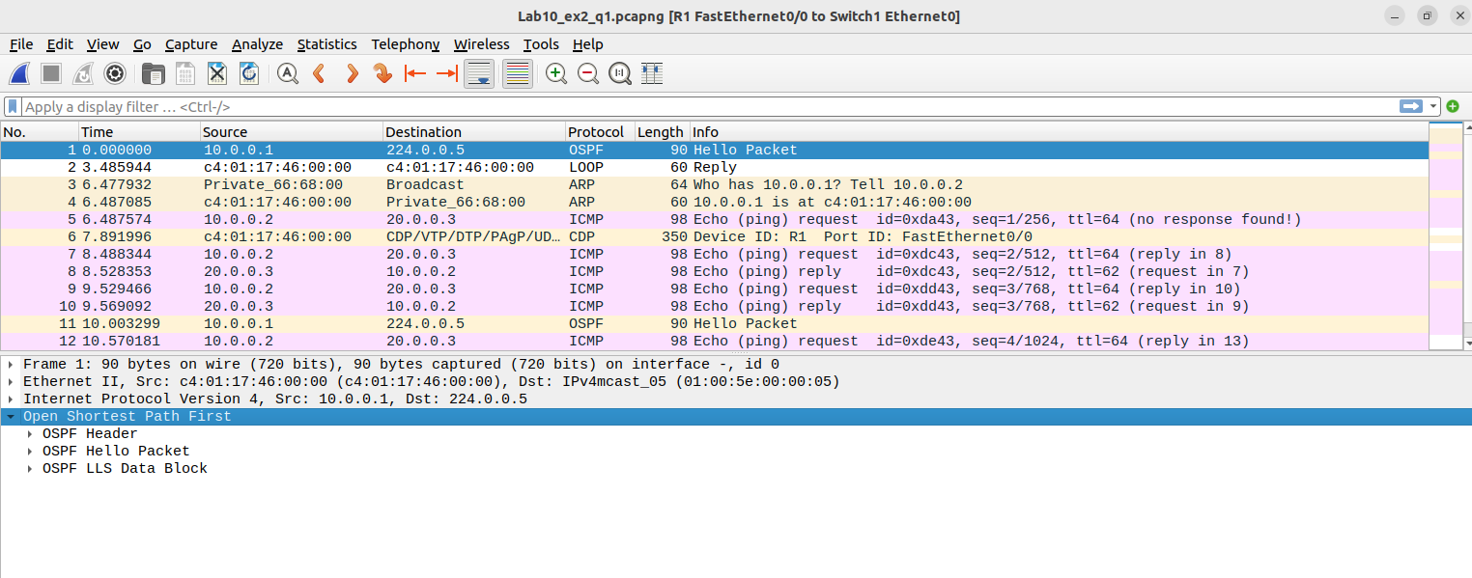

II. Configure the below network topology using RIP and OSPF as shown in Figure and check the
connectivity by pinging from PC1 to PC2, PC3, PC4.

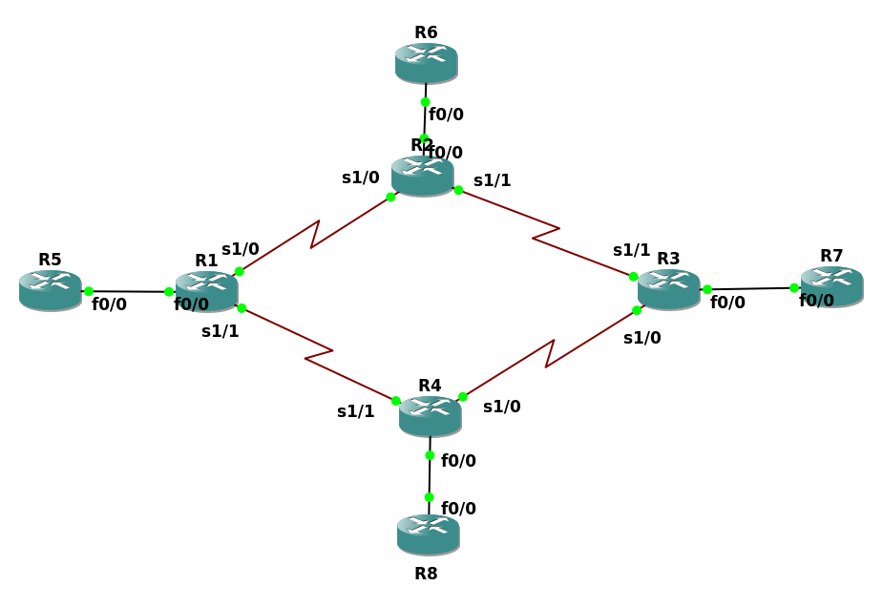
R1#conf t
Enter configuration commands, one per line. End with CNTL/Z.
R1(config)#inter s1/0
R1(config-if)#ip address 10.1.1.1 255.255.255.252
R1(config-if)#no shut
R1(config-if)#exit
*Mar 1 00:00:42.107: %LINK-3-UPDOWN: Interface Serial1/0, changed state to up
R1(config-if)#exit
*Mar 1 00:00:43.111: %LINEPROTO-5-UPDOWN: Line protocol on Interface Serial1/0, changed state to up
R1(config-if)#exit
R1(config)#inter s1/1
R1(config-if)#ip address 10.1.1.14 255.255.255.252
R1(config-if)#
*Mar 1 00:01:03.503: %LINEPROTO-5-UPDOWN: Line protocol on Interface Serial1/0, changed state to down
R1(config-if)#no shut
R1(config-if)#exi
*Mar 1 00:01:15.867: %LINK-3-UPDOWN: Interface Serial1/1, changed state to upt
R1(config-if)#exit
*Mar 1 00:01:16.871: %LINEPROTO-5-UPDOWN: Line protocol on Interface Serial1/1, changed state to up
R1(config-if)#exit
R1(config)#inter f0/0
R1(config-if)#ip address 10.1.1.17 255.255.255.248
R1(config-if)#no shut
R1(config-if)#exit
*Mar 1 00:01:43.207: %LINK-3-UPDOWN: Interface FastEthernet0/0, changed state to up
R1(config-if)#exit
*Mar 1 00:01:43.527: %LINEPROTO-5-UPDOWN: Line protocol on Interface Serial1/1, changed state to down
*Mar 1 00:01:44.207: %LINEPROTO-5-UPDOWN: Line protocol on Interface FastEthernet0/0, changed state to up
R1(config-if)#exit
R1(config)#router rip
R1(config-router)#version 2
R1(config-router)#network 10.1.1.16
R1(config-router)#exit
R1(config)#router rip
R1(config-router)#exit
R1(config)#router ospf 201
R1(config-router)#network 10.1.1.0 0.0.0.3 area 0
R1(config-router)#network 10.1.1.12 0.0.0.3 area 0
R1(config-router)#exit
R1(config)#exit

R2#conf t
Enter configuration commands, one per line. End with CNTL/Z.
R2(config)#inter s1/0
R2(config-if)#ip address 10.1.1.2 255.255.255.252
R2(config-if)#no shut
R2(config-if)#
*Mar 1 00:00:38.115: %LINK-3-UPDOWN: Interface Serial1/0, changed state to up
R2(config-if)#
*Mar 1 00:00:39.119: %LINEPROTO-5-UPDOWN: Line protocol on Interface Serial1/0, changed state to up
R2(config-if)#exit
R2(config)#inter s1/1
R2(config-if)#ip address 10.1.1.5 255.255.255.252
R2(config-if)#no shut
R2(config-if)#
*Mar 1 00:01:18.279: %LINK-3-UPDOWN: Interface Serial1/1, changed state to up
R2(config-if)#
*Mar 1 00:01:19.283: %LINEPROTO-5-UPDOWN: Line protocol on Interface Serial1/1, changed state to up
R2(config-if)#exit
R2(config)#inter f0/0
R2(config-if)#ip address 10.1.1.25 255.255.255.248
R2(config-if)#no shut
R2(config-if)#
*Mar 1 00:01:44.739: %LINK-3-UPDOWN: Interface FastEthernet0/0, changed state to up
*Mar 1 00:01:45.739: %LINEPROTO-5-UPDOWN: Line protocol on Interface FastEthernet0/0, changed state to up
R2(config-if)#exit
R2(config)#router rip
R2(config-router)#version 2
R2(config-router)#network 10.1.1.24
R2(config-router)#exit
R2(config)#
*Mar 1 00:02:33.263: %LINEPROTO-5-UPDOWN: Line protocol on Interface Serial1/1, changed state to down
R2(config)#
*Mar 1 00:04:23.247: %LINEPROTO-5-UPDOWN: Line protocol on Interface Serial1/1, changed state to up
R2(config)#router ospf 201
R2(config-router)#network 10.1.1.4 0.0.0.3 area 0
R2(config-router)#netwo
*Mar 1 00:13:41.903: %OSPF-5-ADJCHG: Process 201, Nbr 10.1.1.33 on Serial1/1 from LOADING to FULL, Loading Done
R2(config-router)#network 10.1.1.0 0.0.0.3 area 0
R2(config-router)#
*Mar 1 00:13:54.927: %OSPF-5-ADJCHG: Process 201, Nbr 10.1.1.17 on Serial1/0 from LOADING to FULL, Loading Done
R2(config-router)#exit
R2(config)#exit

R3#conf t
Enter configuration commands, one per line. End with CNTL/Z.
R3(config)#inter s1/0
R3(config-if)#ip address 10.1.1.9 255.255.255.252
R3(config-if)#no shut
R3(config-if)#
*Mar 1 00:01:02.335: %LINK-3-UPDOWN: Interface Serial1/0, changed state to up
*Mar 1 00:01:03.335: %LINEPROTO-5-UPDOWN: Line protocol on Interface Serial1/0, changed state to up
R3(config-if)#exit
R3(config)#inter s1/1
R3(config-if)#ip address 10.1.1.6 255.255.255.252
R3(config-if)#no shut
R3(config-if)#
*Mar 1 00:01:27.787: %LINK-3-UPDOWN: Interface Serial1/1, changed state to up
R3(config-if)#
*Mar 1 00:01:28.791: %LINEPROTO-5-UPDOWN: Line protocol on Interface Serial1/1, changed state to up
R3(config-if)#exit
R3(config)#inter f0/0
R3(config-if)#ip address 10.1.1.33 255.255.255.248
R3(config-if)#no shut
R3(config-if)#
*Mar 1 00:01:57.559: %LINK-3-UPDOWN: Interface FastEthernet0/0, changed state to up
*Mar 1 00:01:58.559: %LINEPROTO-5-UPDOWN: Line protocol on Interface FastEthernet0/0, changed state to up
R3(config-if)#exit
R3(config)#router rip
R3(config-router)#version 2
R3(config-router)#network 10.1.1.32
R3(config-router)#exit
R3(config)#router ospf 201
R3(config-router)#network 10.1.1.4 0.0.0.3 area 0
R3(config-router)#network 10.1.1.8 0.0.0.3 area 0
R3(config-router)#e
*Mar 1 00:02:51.991: %OSPF-5-ADJCHG: Process 201, Nbr 10.1.1.41 on Serial1/0 from LOADING to FULL, Loading Done
R3(config-router)#exit
R3(config)#exit

R4#conf t
Enter configuration commands, one per line. End with CNTL/Z.
R4(config)#inter f0/0
R4(config-if)#ip address 10.1.1.41 255.255.255.248
R4(config-if)#no shut
R4(config-if)#
*Mar 1 00:00:42.071: %LINK-3-UPDOWN: Interface FastEthernet0/0, changed state to up
*Mar 1 00:00:43.071: %LINEPROTO-5-UPDOWN: Line protocol on Interface FastEthernet0/0, changed state to up
R4(config-if)#exit
R4(config)#inter s1/0
R4(config-if)#ip address 10.1.1.10 255.255.255.252
R4(config-if)#no shut
R4(config-if)#
*Mar 1 00:01:14.675: %LINK-3-UPDOWN: Interface Serial1/0, changed state to up
R4(config-if)#
*Mar 1 00:01:15.679: %LINEPROTO-5-UPDOWN: Line protocol on Interface Serial1/0, changed state to up
R4(config-if)#exit
R4(config)#inter s1/1
R4(config-if)#ip address 10.1.1.13 255.255.255.252
R4(config-if)#no shut
R4(config-if)#
*Mar 1 00:01:39.763: %LINK-3-UPDOWN: Interface Serial1/1, changed state to up
R4(config-if)#
*Mar 1 00:01:40.767: %LINEPROTO-5-UPDOWN: Line protocol on Interface Serial1/1, changed state to up
R4(config-if)#exit
R4(config)#router rip
R4(config-router)#version 2
R4(config-router)#network 10.1.1.40
R4(config-router)#exit
R4(config)#router ospf 201
R4(config-router)#network 10.1.1.8 0.0.0.3 area 0
R4(config-router)#netwo
*Mar 1 00:02:20.819: %OSPF-5-ADJCHG: Process 201, Nbr 10.1.1.9 on Serial1/0 from LOADING to FULL, Loading Done
R4(config-router)#network 10.1.1.12 0.0.0.3 area 0
R4(config-router)#exit

R5#conf t
Enter configuration commands, one per line. End with CNTL/Z.
R5(config)#inter f0/0
R5(config-if)#ip address 10.1.1.18 255.255.255.248
R5(config-if)#no shut
R5(config-if)#
*Mar 1 00:00:38.523: %LINK-3-UPDOWN: Interface FastEthernet0/0, changed state to up
*Mar 1 00:00:39.523: %LINEPROTO-5-UPDOWN: Line protocol on Interface FastEthernet0/0, changed state to up
R5(config-if)#exit
R5(config)#router rip
R5(config-router)#version 2
R5(config-router)#network 10.1.1.16
R5(config-router)#exit

R6#conf t
Enter configuration commands, one per line. End with CNTL/Z.
R6(config)#inter f0/0
R6(config-if)#ip address 10.1.1.26 255.255.255.248
R6(config-if)#no shut
R6(config-if)#
*Mar 1 00:00:37.891: %LINK-3-UPDOWN: Interface FastEthernet0/0, changed state to up
*Mar 1 00:00:38.891: %LINEPROTO-5-UPDOWN: Line protocol on Interface FastEthernet0/0, changed state to up
R6(config-if)#exit
R6(config)#router rip
R6(config-router)#version 2
R6(config-router)#network 10.1.1.24
R6(config-router)#exit

R7#conf t
Enter configuration commands, one per line. End with CNTL/Z.
R7(config)#inter f0/0
R7(config-if)#ip address 10.1.1.34 255.255.255.248
R7(config-if)#no shut
R7(config-if)#
*Mar 1 00:00:56.251: %LINK-3-UPDOWN: Interface FastEthernet0/0, changed state to up
*Mar 1 00:00:57.251: %LINEPROTO-5-UPDOWN: Line protocol on Interface FastEthernet0/0, changed state to up
R7(config-if)#exit
R7(config)#router rip
R7(config-router)#version 2
R7(config-router)#network 10.1.1.32
R7(config-router)#exit

R8#conf t
Enter configuration commands, one per line. End with CNTL/Z.
R8(config)#inter f0/0
R8(config-if)#ip address 10.1.1.42 255.255.255.248
R8(config-if)#no shut
R8(config-if)#
*Mar 1 00:00:38.331: %LINK-3-UPDOWN: Interface FastEthernet0/0, changed state to up
*Mar 1 00:00:39.331: %LINEPROTO-5-UPDOWN: Line protocol on Interface FastEthernet0/0, changed state to up
R8(config-if)#exit
R8(config)#router rip
R8(config-router)#version 2
R8(config-router)#network 10.1.1.40
R8(config-router)#exit

